**SPH3U: 2.1 Motion in Two Dimensions – Scale Diagrams**

1. **Compass directions**

|  |  |
| --- | --- |
| Compass: |  |
| compass rose |  |
| Cartesian grid |  |
| angles between NEWS |  |

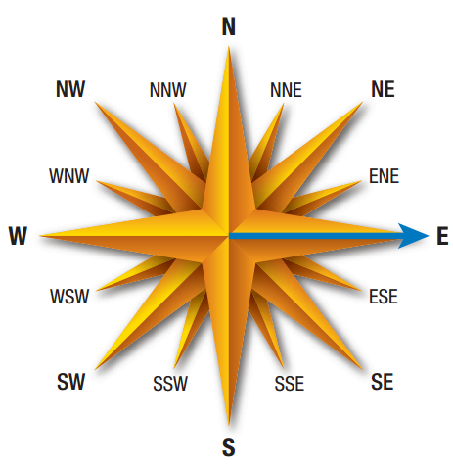 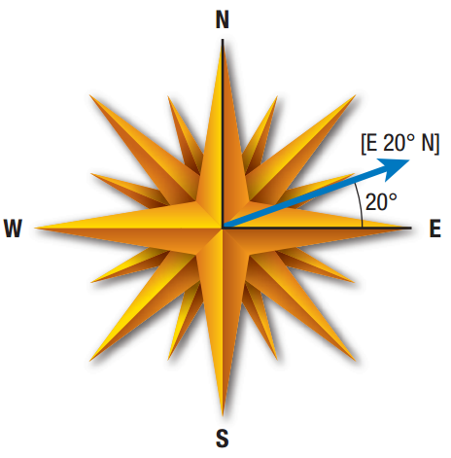

[S15°W] [E63°S] [N85°W]

|  |  |
| --- | --- |
| Scale diagram: |  |
| scale |  |
| resultant vector |  |

Draw a scale diagram of a displacement vector of 41 m [E15°S].

|  |  |
| --- | --- |
| Tip and tail: |  |
| Adding vectors: |  |

A cyclist rides her bicycle 50 m due east, and then turns a corner and rides 75 m due north. What is her total displacement?

While in a race, a sailboat travels a displacement of 40 m [N]. The boat then changes direction and travels a displacement of 60 m [S30°W]. What is the boat’s total displacement?

A squash ball undergoes a displacement of 6.2 m [W25°S] as it approaches a wall. It bounces off the wall and experiences a displacement of 4.8 m [W25°N]. The whole motion takes 3.7 s. Determine the squash ball’s total displacement and average velocity.

**Homework:** page 65: #1-4, 7-8